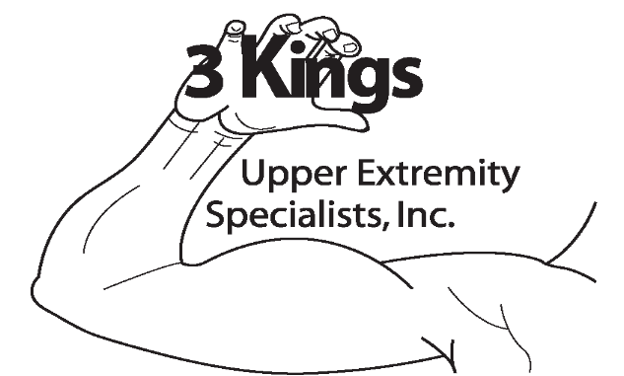is a therapist owned and operated company specializing in Upper Extremity education and services. It’s president, Jennifer T. Dodson, OTR/L,CHT, is a fellowship trained Occupational Therapist and Certified Hand Therapist that has been practicing outpatient rehabilitation in Jacksonville since 1998. Jennifer was honored to be chosen as a fellow of the Evelyn J. Mackin Hand Therapy Fellowship at the Philadelphia Hand Center in 2001. It is a unique educational opportunity where 2 therapists are chosen from around the world every 6 months to train with the hand surgeons and CHTs of the Philadelphia Hand Center. Past fellows have been from various areas of the US, Canada, Puerto Rico, and Ireland. Part of the mission of the fellowship is to educate therapists from underserved areas so that they can bring their knowledge back to those areas. After the fellowship, Jennifer was determined to fulfill the mission of the fellowship by bringing her knowledge and services back to the Jacksonville area. Her passion and dedication to the field of hand therapy lead her to developing the company. The objectives of the company are:

*Provide quality continuing education courses and services specializing in upper extremity rehabilitation
*Provide mentoring to therapists that are interested in hand therapy or find themselves seeing patients with UE dysfunction
*Provide networking opportunities for healthcare professionals
*Promote evidenced based practice
*Stimulate research
*Foster therapist/MD collaboration
*Be a resource to the community for the latest advancements in the field
*Increase the awareness of Hand Therapy and the Certified Hand Therapist Certification

We hope that you will join us for the next upper extremity course and please feel free to contact us with any suggestions of topics you would like to see come to the Jacksonville area. The courses we provide are based on your requests to optimize your learning experience.

